MS5105 First Individual Assignment
Name: Raviraj Bhandari, Student ID: 24230491
Self-declaration:
“In submitting this work, I confirm that it is entirely my own. I acknowledge that I may be invited to online interview if there is any concern in relation to the integrity of my submission, and I am aware that any breach will be subject to the University's Procedures for dealing with breaches of Exam Regulations. I am aware of what the University of Galway plagiarism policy entails.”

Questions for Assignment:
- Note: I have taken 3 questions presenting 3 statistical techniques used and all questions fall under quantitative analysis and performed normality check for all the questions.

Question1: Marriage and life satisfaction: Independent T-Test
Question: Check the relationship between life satisfaction level between married and unmarried individuals?

Variables:
- Categorical variable: Marital Status (marital): for this analysis we need to compare married and remarried (value 4-5) vs not married or unmarried (value 1,2,3,6,7,8)
- Continuous variable: Total life satisfaction (tlifesat)
- Variables: Life satisfaction (quantitative, continuous), marital status (categorical, used as a grouping variable).
- Falls under Quantitative – Life satisfaction is a continuous, quantitative variable.

SPSS steps:

Normality check for life satisfaction:
- Go to Analyze → descriptive statistics → explore.
- Move Tlifesat → dependent list and Martial_grouped or Martial → Factor list. (I did for both)
- Click on Plot, checkbox histogram and normality plots with tests continue and ok.
- After the check got results as (for martial):
- Groups with Shapiro-Wilk p>0.05 (indicating normality):
- Single (p = 0.073), Steady Relationship (p = 0.720), Living with Partner (p = 0.334), Remarried (p = 0.118), Separated (p = 0.885), Divorced (p = 0.061), Widowed (p = 0.832).
- Groups with Shapiro-Wilk p<0.05 (indicating non-normality):
- Married First Time (p < 0.001)
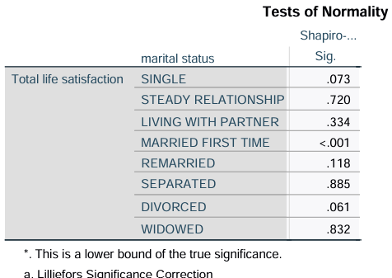
After the check got results as (for Martial_grouped):
Married (Group 1): Shapiro-Wilk p<0.001, indicating a significant deviation from normality.
Unmarried: Shapiro-Wilk p=0.073, which is greater than 0.05, suggesting that this group does not deviate from normality.
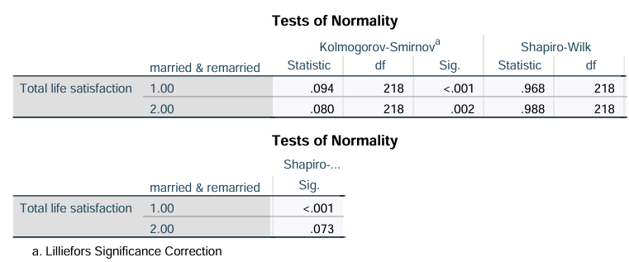
**Thus, from both normality check, there is only minor deviation for normality in 1 group, so we can proceed with independent t-test, but as its non-parametric we could have used Mann-Whitney U test, as assignment doesn’t require non-parametric tests, so we processed with independent t-test.

Analysis Check Independent T-Test:
Steps followed as per lecture notes from week 5- 7.
- Note: Now here as we cannot use multiple values to define group so we can recode the martial status variables into 2 groups, 1 contains married and another contains unmarried.
- Recode the Marital Status Variable:
- Go to transform → Recode into different variables.
- Go to Marital Status variable (Marital) put under input variable box → output variables.
- Under output variables name box, give new variable name like Marital_Grouped.
- Define the Recode Values:
- Go to old and new option.
- Under option for old value enter each value for Group 1 separately (4 and 5 for married/remarried), setting the New Value to 1 for both.
- For Group 2 (unmarried individuals with values 1, 2, 3, 6, 7, and 8), set the New Value to 2.
- Click Add after each value pairing, so all values are recoded as either 1 or 2.
Now Run the Independent Samples T-Test:
- Used the new Marital_Grouped variable as the new variable for Grouping.
- Define Group 1 as 1 (married) and Group 2 as 2 (unmarried).

Results and Interpretation:
Result: (filename: Q1Analysis.pdf, for output files)
- Group statistics: Married Group (1): Mean life satisfaction = 23.57, SD = 6.676, N = 218, Unmarried Group (2): Mean life satisfaction = 21.19, SD = 6.667, N = 218.
- Thus, mean difference between Married group and unmarried group where mean for married are higher than unmarried groups. (from diagram 1 is for married and 2 is for unmarried).
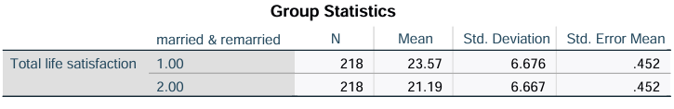
- T-Test for Equality of Means:
- t(434) = 3.726, p < 0.001: Here it indicates significant difference in life satisfaction between married and unmarried individuals.
- Mean Difference: 2.38 points, suggesting that individuals who are married reports higher life satisfaction on average.

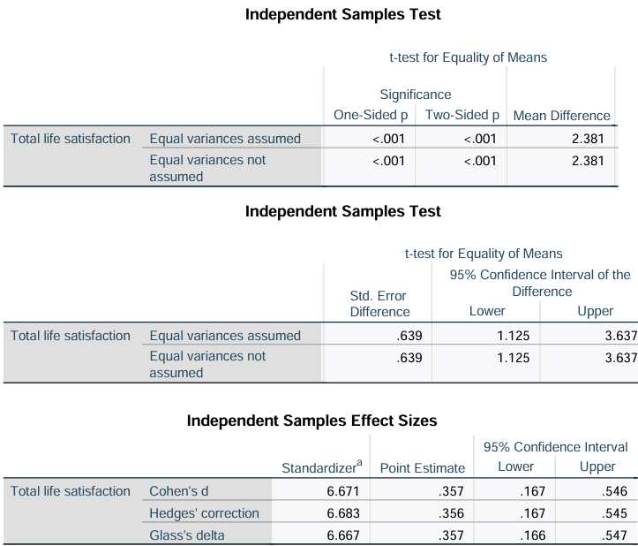

Conclusion:
This suggests that marital status is associated with life satisfaction, with married individuals experiencing higher satisfaction levels on average than unmarried individuals.

Question2: Marriage and optimism levels: One-way Anova
Question: Check if marital status affects optimism levels or not?

Variables:
- Categorical variable: Marital Status (marital): categories include:
- 1 for single, 2 for steady relationship... 8 for widowed.
- Continuous variable: Total optimism (Toptim)
- Variables: Optimism (quantitative, continuous), marital status (categorical, used as a factor).
- Falls under Quantitative – Optimism is a continuous, quantitative variable.

SPSS steps:
Normality check for Optimism by Marital Status followed same step used in Question 1 for normality check. After the normality check we got:
- Groups with Shapiro-Wilk p>0.05 (indicating normality):
- Single (p = 0.056), Steady Relationship (p = 0.428), Separated (p = 0.955), Divorced (p = 0.529)
- Groups with Shapiro-Wilk p<0.05 (indicating non-normality):
- Living with Partner (p = 0.009), Married First Time (p = 0.003), Remarried (p = 0.004), Widowed (p < 0.001).
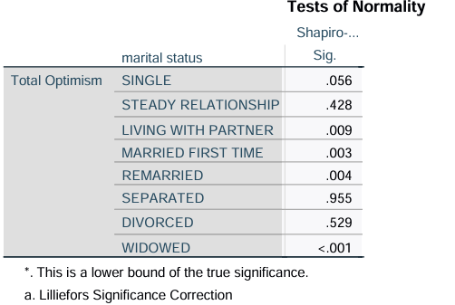
**Thus, there is deviation for normality, but as Anova is robust to normality when it’s large dataset, we can proceed with One-way Anova, but as its non-parametric we could have used Cochran’s test, as assignment doesn’t require non-parametric tests, so we processed with one-way Anova.

Analysis steps One-Way Anova:
Followed same steps from lecture notes week 5-7.

Results and Interpretation:
Result: (filename: Q2Analysis, for output file)
- Descriptive analysis
Optimism score ranges from mean of 18.50 for separated to 25.57 for widowed group. Thus, showing or we can assume that separated has lower optimism than widow.
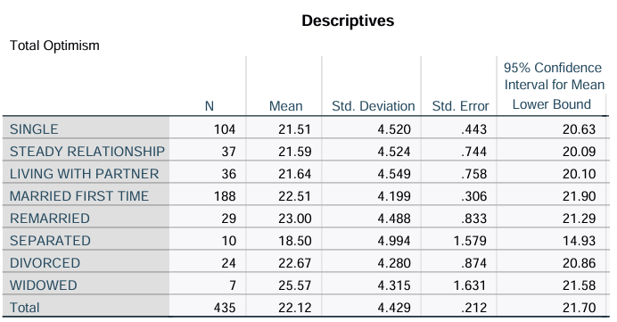
- Levene’s test for homogeneity of variance
Levene’s Statistic = 0.264, p = 0.967: The p-value is above 0.05, indicating that variances across marital status groups are equal, so it fits with our homogeneity assumption.
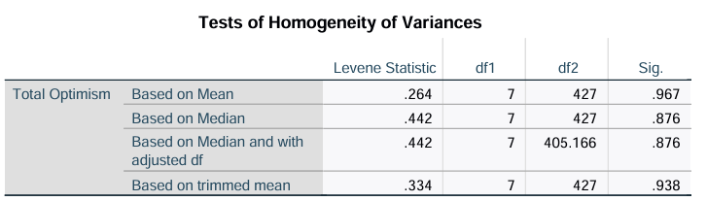
- Anova Test
F (7, 427) = 2.454, p = 0.018: This result indicates that one marital status group differs in optimism. In descriptive we saw separated individuals.
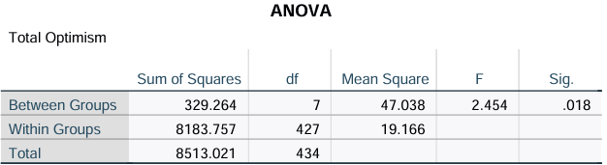
- Effect-size (ETA-squared)
Eta-squared = 0.039: A small effect size, meaning marital status explains about 3.9% of the variance in optimism levels, indicating a modest practical impact.
To validate ETA: we took between group value 329.264 divided (/) by total value 8513.021 from ANOVA table, so this comes around 0.39 which is satisfying our eta-squared value.
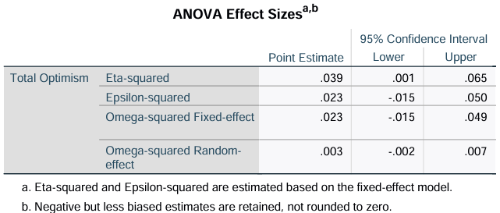
- Post-hoc analysis (turkey HSD)
Separated and Married First Time groups, with a mean difference of -7.071 (p = 0.025), indicating that separated individuals have significantly lower optimism than those married for the first time.
So, in below diagram we can see the difference of 7.071 for separated and widowed.
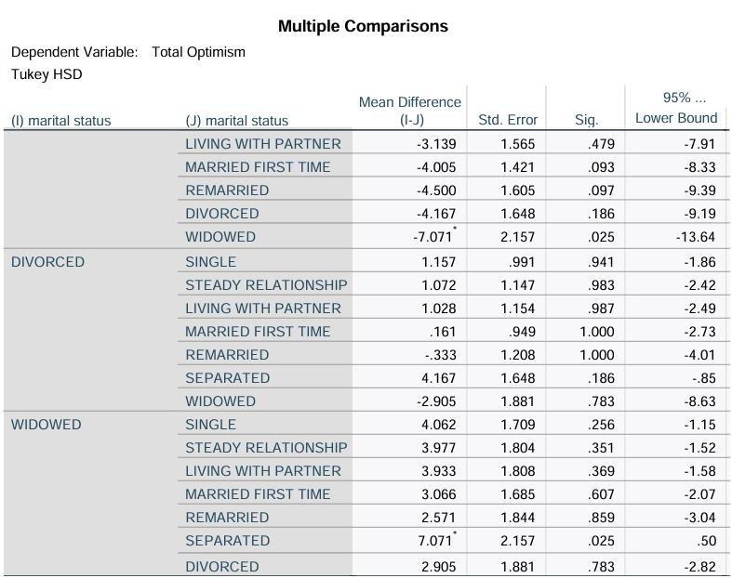
- Mean Plot:
This shows optimism difference across martial groups and highlights lower optimism for separated individuals and higher optimism for widowed individuals.
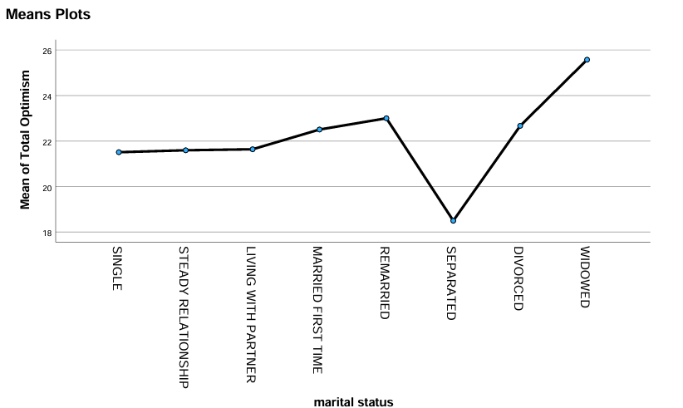

Conclusion:
Test shows that marital status impacts optimism levels, so here separated individual have lower optimism and then the married ones, and widowed individuals have higher optimism levels.

Question3: Age Group and smoking on Optimism: Two-way Anova
Question: Does age group and smoking affect optimism?

Variables:
- Age group (3 categories) (Agegp3)
- Smoking Status (smoke)
- Total optimism (Toptim)
- Variables: Optimism (quantitative, continuous), age group (categorical), smoking status (categorical).
- Falls under Quantitative – Optimism is a continuous, quantitative variable.

SPSS Steps:
Normality check for Optimism across age group and optimism followed as normality check as Question 1. After the normality check we got:
Shapiro-Wilk Test for Normality:
- Age Group 18-29: Shapiro-Wilk p=0.002, indicating a deviation from normality.
- Age Group 30-44: Shapiro-Wilk p=0.009 also indicating a deviation from normality.
- Age Group 45+: Shapiro-Wilk p<0.001, confirming non-normality for this group.
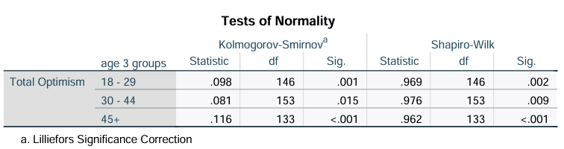
**Thus, from both, there is only one minor deviation for normality in 1 group, but as discuss earlier Anova is robust to normality when it’s large dataset, so we can proceed with Two-way Anova, but as its non-parametric we could have used McNemar test, as assignment doesn’t require non-parametric tests, so we processed with two-way Anova.

Analysis Steps Two-Way Anova
Steps followed as per lecture notes from week 5- 6.

Results and Interpretation:
Result: (filename: Q3Analysis for output file)
- Description Statistics:
- Optimism scores by age and smoking status range from mean of 20.50 (smokers age: 18-29) to 23.17 (smokers age 45+). This shows that mean is higher for older individuals (45+)
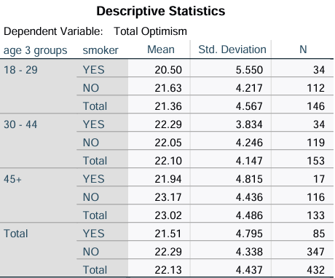
- Levene’s test for homogeneity of variance
- Levene's Statistic = 2.085, p = 0.066: Since p>0.05, we can say that variance is equal across groups, meeting the homogeneity assumption required for ANOVA.
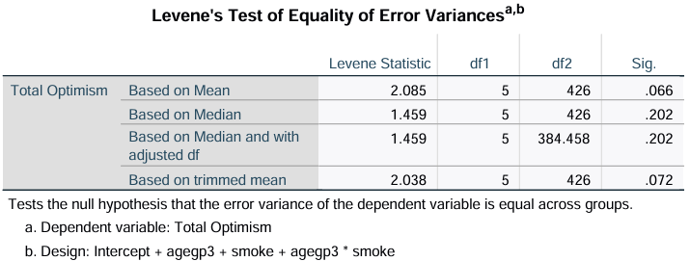
- Anova: F (2, 426) = 2.720, p = 0.067, this shows no difference in optimism level for age groups, F (1, 426) = 1.607, p = 0.206, this shows no difference in optimism level on smoking status, F (2, 426) = 0.825, p = 0.439, interaction between age group and smoking, showing smoking status does not affect relation between age and optimism.
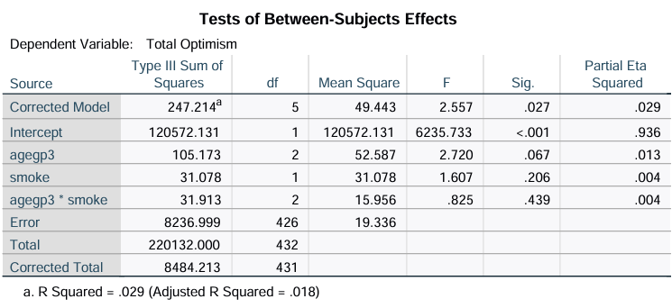
- Post-hoc test (Tukey): Age 18-29 and 45+: mean difference= -1.65, p= 0.005. This suggests that individuals aged 45+ have higher optimism aged 18-29.
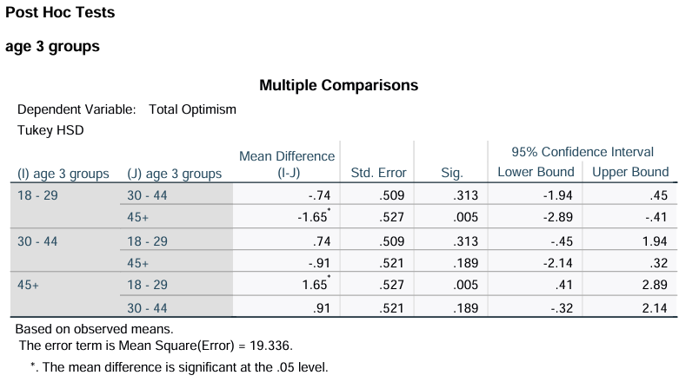
- Plots
Below plot shows optimism score by age group and smoking status. As there is no visible interaction if we see line for smokers and non-smokers are nearly parallel across age groups, providing us result for no interaction effect for Anova.
But we have a difference between smoker and non-smoker where non-smoker have higher optimism.
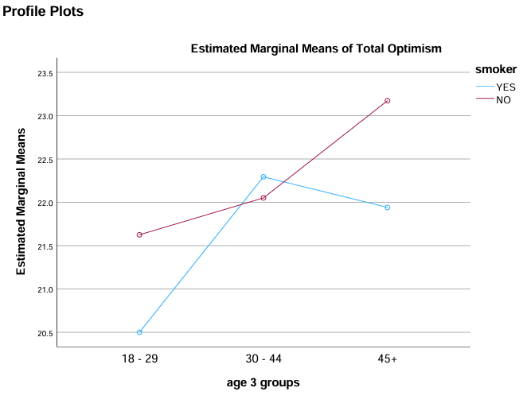

Conclusion:
As per the results two-way Anova for age and smoking don't have any significance on optimism, indicating that optimism does not impact with age and their smoking status.
But through post-hoc analysis there we have a small significant difference between individual aged 45+ and 18-29 age groups, with 45+ age group people have higher optimism and non-smokers tend to report slightly higher optimism.

